Name:  Teacher: | ____________________________________  ________________ |  | Date:_________
 | Year 9 Mathematics  SCORE: / 28  Mini test 4  Topic – Data Analysis  Full working out MUST be shown to get full marks for each question.
Total Time: | 30 minutes
Weighting: | 5 %
Equipment: | To be provided by the student: Pens and Pencils, scientific calculator, A4 page of notes.

- Underneath each graph below, write the most appropriate term to describe the distribution.
a) b) [4 marks]
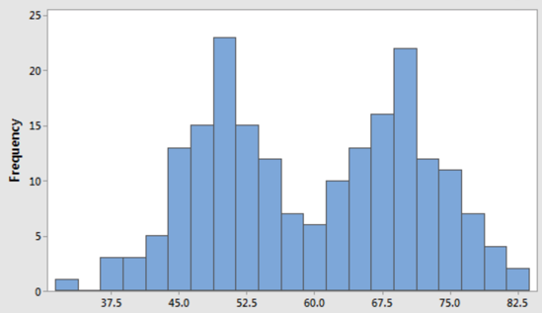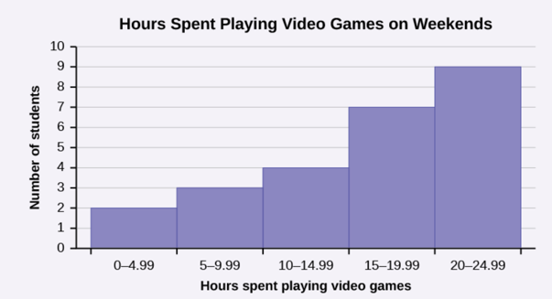

c) d)
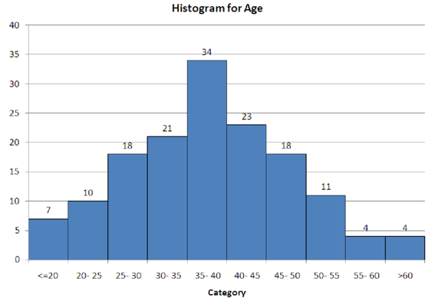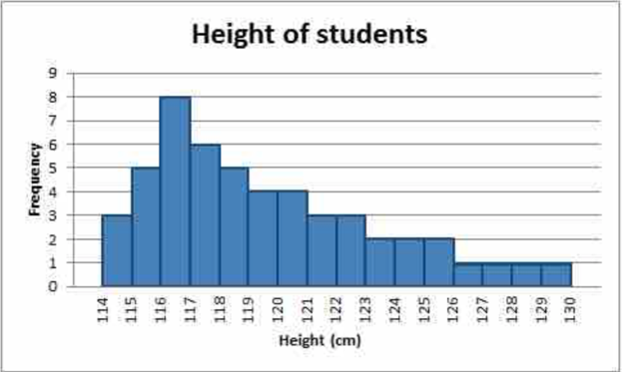

2. Isagani and Lara were arguing whose basketball team was better. They looked at the scores from their games last year: [1,3,1,2,2,3 - 12 marks]

Isagani’s team 55, 78, 84, 98, 77, 86, 88, 101, 95, 32, 65, 63, 75, 81, 59
Lara’s team 47, 34, 38, 100, 54, 51, 43, 42, 47, 58, 65, 57, 85, 91, 63

- Is the above data continuous or discrete?

- Display the above data using the appropriate graphical display

- Describe the shape of both team’s data.

- Calculate each team’s:

- Median

- Range

- Decide which team performed better last year? Justify your answer.

3) The data below is information about the number of hours worked by different employees during 1 week at Built Fast Enterprises. [3 + 4 + 2 + 3 = 12 marks]

Week 1 data: 14, 17, 6, 42, 18, 13, 16, 17, 40, 19, 39, 31, 37, 45, 30, 21, 22, 38, 39, 36, 48, 49, 18

- create a frequency table for this data.

- Use the frequency table to create a histogram.



- Comment on the shape of the data in the histogram.

- Later, Built Fast analysed two separate weeks to look at the productivity of their employees during their working hours. They compiled their results below:
Week 2
Week 1

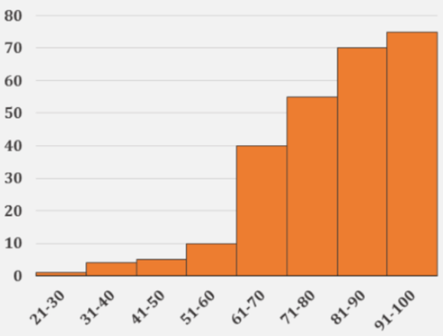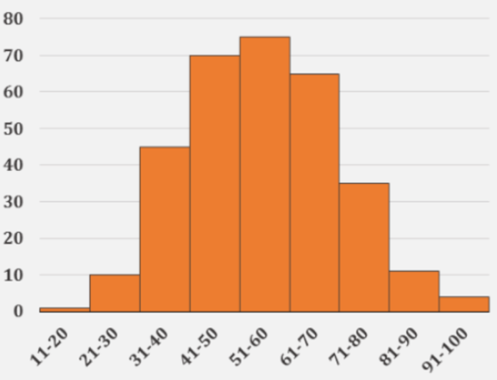
Units Built
Units Built
Number of Employees
Number of Employees

Comment on the distribution of both data sets and explain which week was more productive, using specific reference to how each week’s distribution impacts the measures of centre.

